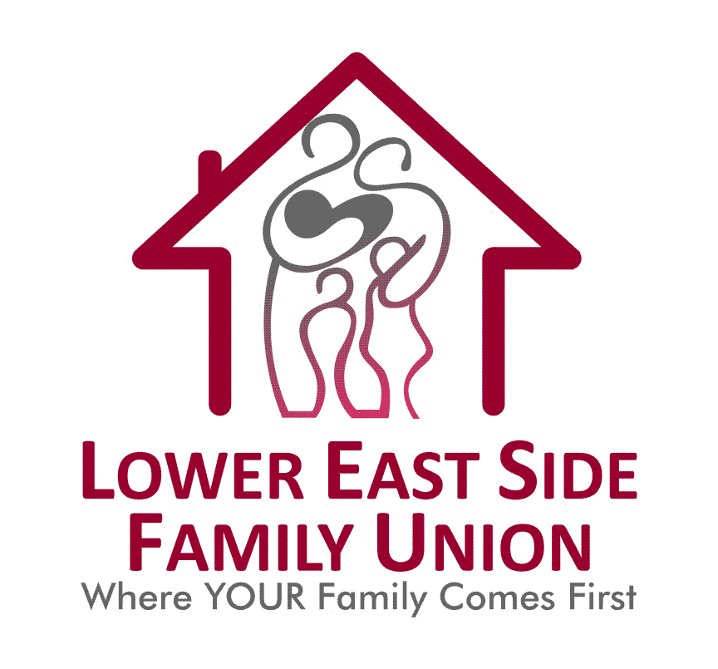

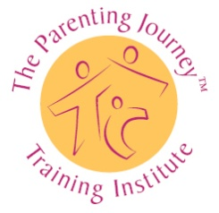

Refreshments and Fun

English Speaking

Parents will increase their self-care practices, raise awareness of the past and present factors that influence their parenting styles, enhance their parenting Skills, and utilize their strengths to support their children and build nurturing family relationships.

July 18, 2017 10:00 am – 12:00 pm and every Tuesday for 12-Weeks

**Lower East Side Family Union**

**227 East 3rd Street**

**New York, NY 10009**

**To Register/More Information Contact:**

**Latiefa Hook**

**(212) 260-0040 ext. 1248**

[**lhook@lesfu.org**](mailto:lhook@lesfu.org)

**LOWER EAST SIDE FAMILY UNION**

**84 STANTON STREET**

**(LARGE CONFERENCE ROOM)**

**2ND FLOOR**

**(ENTRANCE ON ALLEN STREET)**

**Tel: (212) 260-0040 Ext 220**

**(for further information)**

**Email: http://www.lesfu.org**